EXPERIMENT 2
Dynamic Response Studies on a V/f Controlled
Induction Motor Drive
EE208 : CONTROL ENGINEERING LAB

Experiment Report Submitted by
Group ____
[Name 1] [Roll Number]
[Name 2] [Roll Number]
[Name 3] [Roll Number]

Aim
To study the steady-state and dynamic performance of a three-phase squirrel-cage induction motor operated under V/f (scalar) control on a Siemens SINAMICS V20 Variable Frequency Drive (VFD), and to determine how the dominant speed time constant of the motor-drive combination changes with the operating frequency.

Objectives
- Operate the Siemens V20 drive in Manual (Hand) mode and record the steady-state inverter voltage, current, DC-link voltage and shaft speed as the set frequency is stepped from 0 to 50 Hz.
- Repeat the sweep in Automatic mode (potentiometer-controlled frequency) for both clockwise (CW) and anticlockwise (ACW) rotation, and compare the two directions.
- Verify that the drive holds an approximately constant V/f ratio across the constant-torque region and identify where/why it deliberately departs from this at low frequency.
- Extract the step-response speed-vs-time curve of the drive from recorded video at four frequency set points (15, 30, 45 and 50 Hz) and determine the effective time constant (time to reach 63.2% of the final speed) at each.
- Identify and explain the principal non-idealities observed relative to the idealised V/f model.

Theoretical Background

1. Rotating field, synchronous speed and slip
A balanced three-phase current in the stator windings of an induction motor produces a rotating magnetic field (RMF) that sweeps around the air-gap at the synchronous speed
Ns = 120 f / P
where f is the supply frequency and P is the number of poles. The rotor is dragged around by this field but, for any net torque to be produced, it must always turn slightly slower than the field; the fractional shortfall is the slip, s = (Ns − Nr)/Ns. Because Ns is fixed by f once P is fixed, controlling f is, at a small and fairly constant slip, effectively the same as controlling the shaft speed — this is the whole motivation for a variable-frequency drive.

2. Why voltage must be varied together with frequency
The r.m.s. e.m.f. induced per phase in the stator is, from Faraday's law applied to a sinusoidally-distributed winding,
E = 4.44 f Φm Nph kw
so that the working air-gap flux Φm is proportional to E/f, and, since the stator impedance drop is small by design, approximately proportional to V/f. If f were increased while V were held fixed, Φm would fall and the motor would lose torque capability; if f were reduced with V fixed, Φm would rise and drive the core into saturation, causing an excessive, largely reactive magnetising current and additional core loss. Keeping the ratio
Φm ∝ V/f = constant
constant — the V/f control law — keeps the flux, and therefore the torque-producing capability of the machine, essentially unchanged over the whole speed range in which voltage can still be varied in proportion to frequency.

3. Choice of operating flux and the B-H knee
The target flux level is a compromise: too little flux under-uses the iron and limits torque per ampere; too much drives the core past the knee of its B-H curve, where a disproportionate rise in magnetising current buys almost no extra flux, at the cost of extra copper and core loss. Manufacturers therefore choose the rated V/f ratio so that, at rated frequency, the machine sits just at this knee — maximum usable flux for a sensible magnetising current.

4. Realising V/f control in the Siemens V20
The V20 performs the standard two-stage AC–DC–AC conversion used in almost all low-voltage VFDs:
- Rectifier — a diode bridge converts the incoming single-phase 230 V, 50 Hz supply to a pulsating DC.
- DC link — a bank of electrolytic capacitors smooths this into a stiff, low-ripple DC bus (nominally √2 × 230 ≈ 325 V).
- Inverter — a pulse-width-modulated (PWM) three-phase bridge re-synthesises an AC waveform from the DC bus, with the control firmware setting both the output frequency and, through the modulation index, the output voltage so that V/f is held constant.
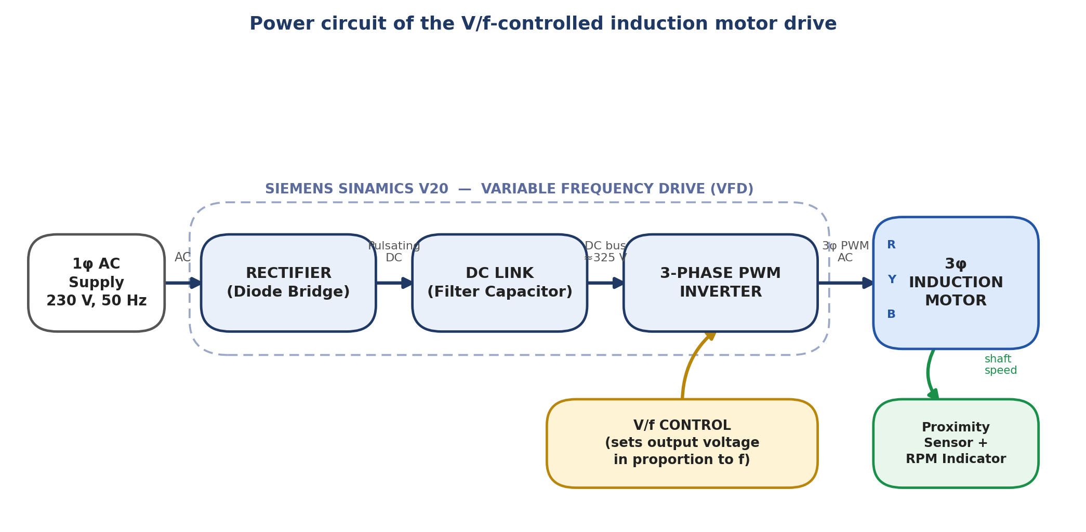
Fig. 1 — Power-circuit block diagram: single-phase supply → rectifier → DC link → PWM inverter → three-phase motor, with the V/f control law setting inverter output voltage from the commanded frequency, and the proximity-sensor/RPM-indicator loop providing the speed readout.
Because the inverter can never output more than the DC-bus voltage allows, constant V/f can only be sustained up to the motor's rated frequency (50 Hz for the machine used here) — the constant-torque region within which this entire experiment was carried out. Beyond rated frequency the voltage saturates while f keeps rising, so V/f (and hence flux) falls off; this constant-power / field-weakening region was not explored, since the drive was kept within 0–50 Hz throughout.

5. Manual vs Automatic mode on the V20
- Manual (Hand) mode — the green/red front-panel keys start and stop the motor; the output frequency is stepped by hand with the UP/DOWN keys after navigating to the DC323 display (via the OK key, which cycles the panel through voltage → current → DC323). Readings were logged once each frequency had settled.
- Automatic mode — with macro Cn007 and parameter P1000 set to 2, the output frequency instead follows the front-panel potentiometer continuously; switch D1 starts/stops the drive and switches D2/D3 select clockwise or anticlockwise rotation. This mode was used to sweep frequency smoothly in both directions.

Experimental Setup
All measurements were taken on a SAP Engineers & Consultants ‘AC Motor Speed Control Trainer’ (model SAP-53). The unit integrates the Siemens SINAMICS V20 VFD, a digital RPM indicator fed from a shaft-mounted proximity sensor, and the front-panel controls (terminals, direction switches and potentiometer) described in the lab manual, all in a single bench-top enclosure with the motor mounted on top.
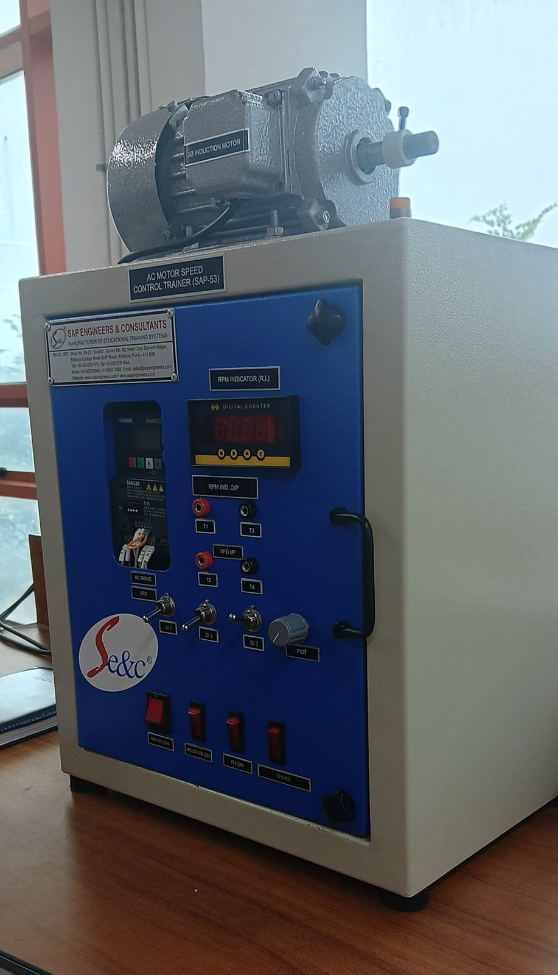
Fig. 2 — The SAP-53 AC Motor Speed Control Trainer used for this experiment: the 3φ induction motor sits on top of the enclosure, driven by the Siemens V20 VFD visible on the front panel.
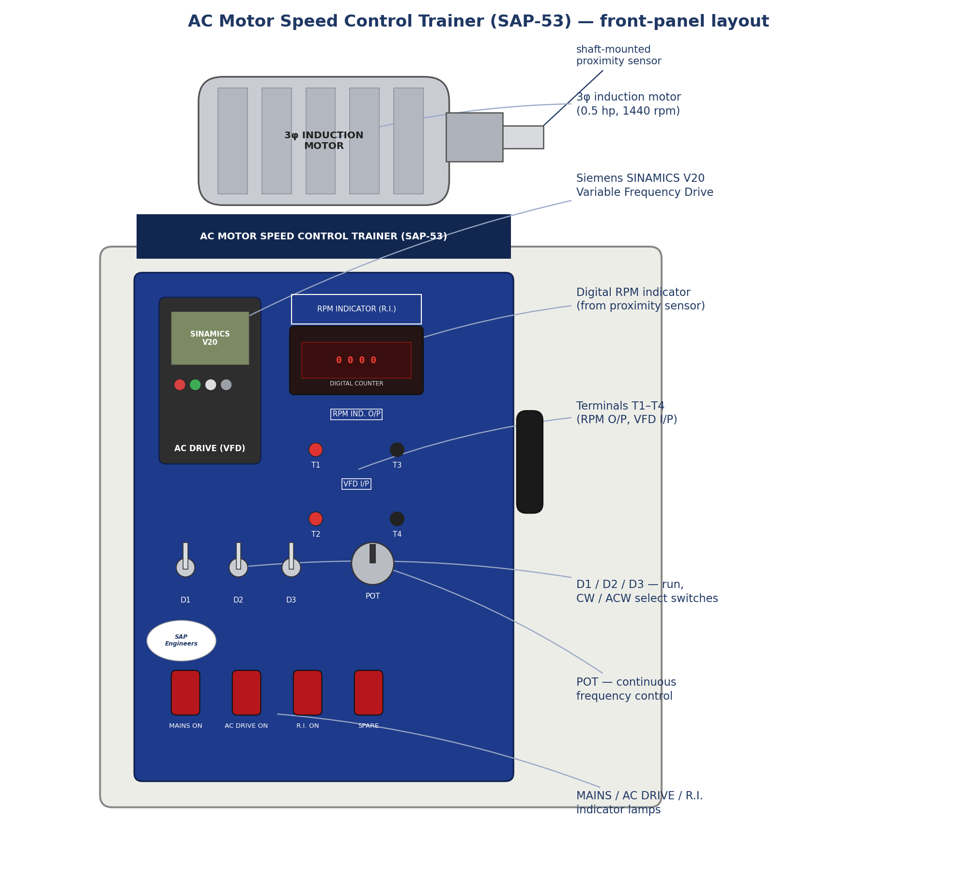
Fig. 3 — Labelled front-panel layout of the trainer: (1) induction motor with shaft-mounted proximity sensor, (2) Siemens SINAMICS V20 VFD, (3) digital RPM indicator, (4) terminals T1–T4 (RPM output / VFD input), (5) switches D1–D3 for run and direction selection, (6) POT for continuous frequency control, and (7) MAINS/AC-DRIVE/R.I. indicator lamps.

Results: Manual Mode (Steady State)
With the drive in Hand mode and the motor unloaded, the frequency was stepped from 0 to 50 Hz and the inverter voltage, current, DC-link voltage and shaft speed were noted at each setting once steady. All runs below are for clockwise rotation.
Frequency (Hz) | Inverter Voltage (V) | Inverter Current (A) | Motor Speed (RPM) | DC Link Voltage (V)
0 | 12 | 1.60 | 0 | 337
2 | 20 | 0.92 | 60 | 335
4 | 28 | 1.10 | 120 | 335
6 | 35 | 1.16 | 180 | 332
8 | 44 | 1.19 | 240 | 331
10 | 52 | 1.19 | 301 | 333
12 | 60 | 1.19 | 361 | 332
14 | 69 | 1.19 | 421 | 332
16 | 78 | 1.20 | 481 | 333
18 | 87 | 1.20 | 542 | 332
20 | 96 | 1.20 | 602 | 332
25 | 118 | 1.20 | 753 | 332
30 | 140 | 1.20 | 904 | 330
35 | 163 | 1.20 | 1054 | 332
40 | 185 | 1.19 | 1205 | 332
45 | 208 | 1.19 | 1355 | 332
50 | 230 | 1.20 | 1506 | 332
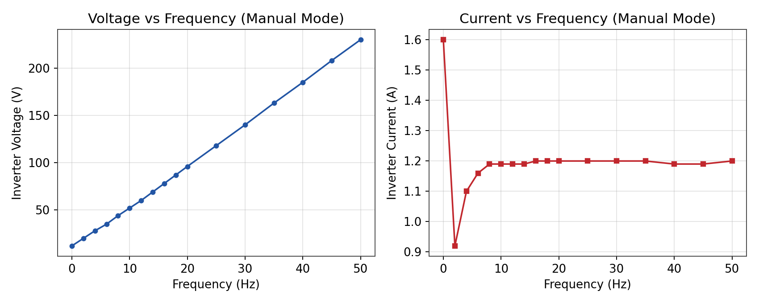
Fig. 4 — Inverter voltage and current vs frequency (Manual mode, CW).
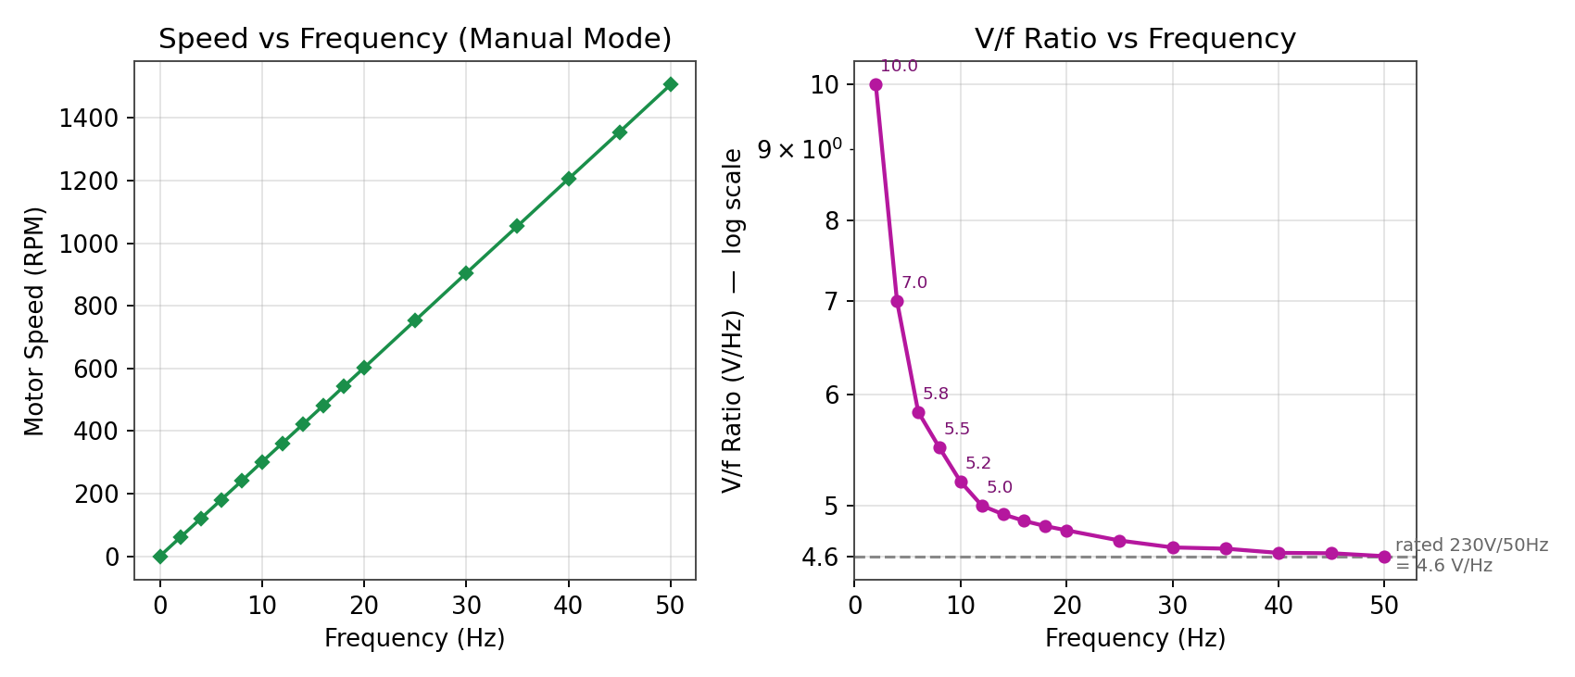
Fig. 5 — Motor speed and the V/f ratio vs frequency (Manual mode, CW).
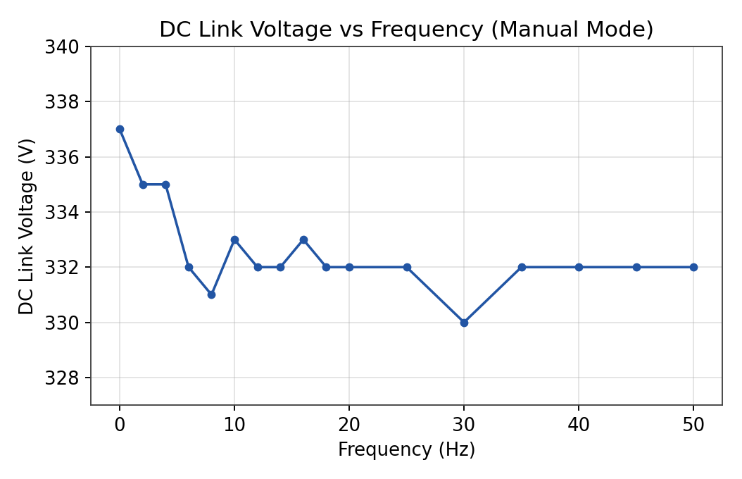
Fig. 6 — DC-link voltage vs frequency (Manual mode, CW).

Observations
Parameter | Observed Trend | Interpretation
Inverter voltage vs frequency | Rises almost linearly from 12 V (0 Hz) to 230 V (50 Hz). | Confirms the drive is holding V ∝ f as designed; the full-scale ratio 230/50 = 4.6 V/Hz matches the motor's own 230 V, 50 Hz nameplate rating.
V/f ratio | ≈ 10 V/Hz at 2 Hz, falling quickly to settle in a 4.6–4.9 V/Hz band beyond ≈10 Hz. | The elevated low-frequency ratio is a deliberate voltage boost that offsets the IsRs drop across the stator winding, without which the motor could not develop starting torque.
Inverter current | Reads 1.60 A at the very first (0 Hz) point, drops to 0.92 A at 2 Hz, then climbs back and flattens near 1.20 A beyond ≈10 Hz. | The isolated high reading at 0 Hz coincides with the instant the inverter is enabled, before the frequency loop has settled; once running, current follows the expected magnetising-current profile — high (relatively) at low flux-build-up, then flat under no load.
DC-link voltage | Stays within 330–337 V (≈ 2%) across the whole sweep. | Confirms good regulation of the rectifier/capacitor stage; the bus is essentially decoupled from the switching load presented by the inverter.
Speed vs frequency | Rises almost linearly, 0 → 1506 RPM as f goes 0 → 50 Hz. | Tracks the synchronous-speed line Ns = 120f/P = 30f (a 4-pole, 1500-RPM-synchronous machine) with only the small negative offset expected from no-load slip.

Results: Automatic Mode (CW and ACW)
In Automatic mode the potentiometer was turned smoothly from zero to full scale while voltage, current, frequency, speed and DC-link voltage were logged; this was repeated for both directions of rotation to check for symmetry.

Clockwise
Inverter Voltage (V) | Inverter Current (A) | Frequency (Hz) | Motor Speed (RPM) | DC Link Voltage (V)
13 | 0.65 | 0.19 | 5 | 332
20 | 0.91 | 2.04 | 61 | 334
28 | 1.09 | 4.00 | 120 | 333
35 | 1.15 | 5.82 | 175 | 332
44 | 1.18 | 8.01 | 241 | 332
50 | 1.19 | 9.57 | 288 | 332
52 | 1.19 | 10.02 | 301 | 331
60 | 1.20 | 11.81 | 356 | 332
70 | 1.20 | 14.24 | 428 | 332
75 | 1.20 | 15.35 | 462 | 333
80 | 1.20 | 16.48 | 496 | 332
90 | 1.20 | 18.74 | 564 | 333
100 | 1.20 | 21.02 | 633 | 332
120 | 1.20 | 25.45 | 766 | 332
140 | 1.20 | 29.90 | 901 | 333
160 | 1.20 | 34.43 | 1035 | 332
180 | 1.19 | 38.80 | 1169 | 332
200 | 1.19 | 43.40 | 1307 | 332
220 | 1.20 | 45.47 | 1370 | 332
230 | 1.20 | 50.00 | 1506 | 332

Anticlockwise
Inverter Voltage (V) | Frequency (Hz) | Inverter Current (A) | Motor Speed (RPM) | DC Link Voltage (V)
13 | 0.19 | 0.64 | 5 | 336
20 | 2.02 | 0.90 | 60 | 335
28 | 4.22 | 1.09 | 126 | 334
35 | 5.92 | 1.15 | 177 | 333
44 | 8.30 | 1.18 | 250 | 333
50 | 9.52 | 1.19 | 286 | 333
52 | 10.00 | 1.19 | 301 | 333
60 | 11.86 | 1.19 | 357 | 333
70 | 14.32 | 1.19 | 431 | 332
75 | 15.43 | 1.19 | 464 | 332
80 | 16.50 | 1.20 | 497 | 332
90 | 18.68 | 1.20 | 562 | 332
100 | 21.00 | 1.20 | 632 | 332
120 | 25.52 | 1.19 | 769 | 332
140 | 30.00 | 1.19 | 902 | 332
160 | 34.40 | 1.19 | 1036 | 332
180 | 38.74 | 1.18 | 1166 | 332
200 | 43.19 | 1.18 | 1301 | 331
210 | 45.60 | 1.18 | 1374 | 331
230 | 50.00 | 1.19 | 1506 | 331
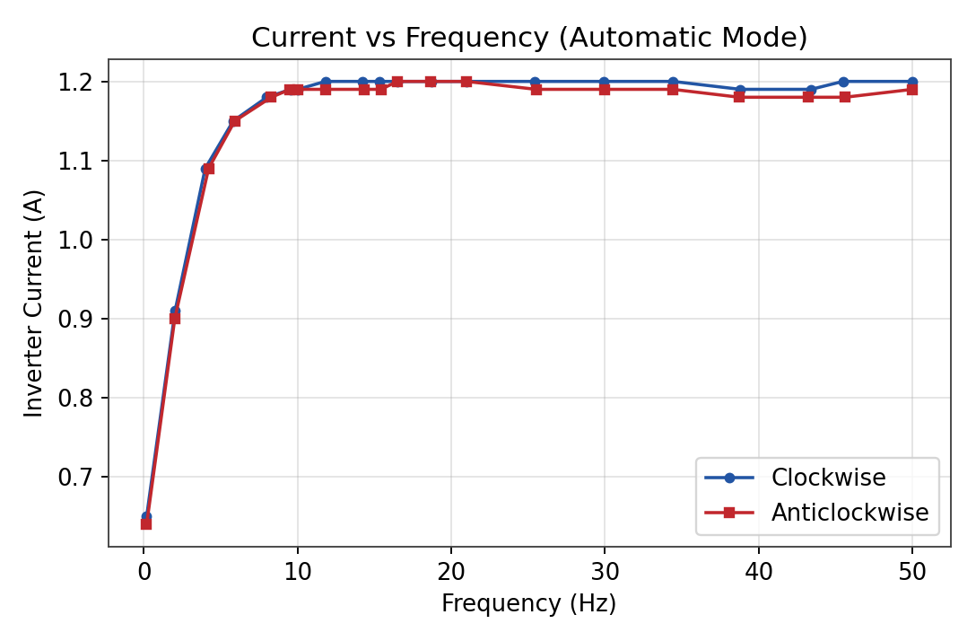
Fig. 7 — Inverter current vs frequency, Automatic mode, CW and ACW.
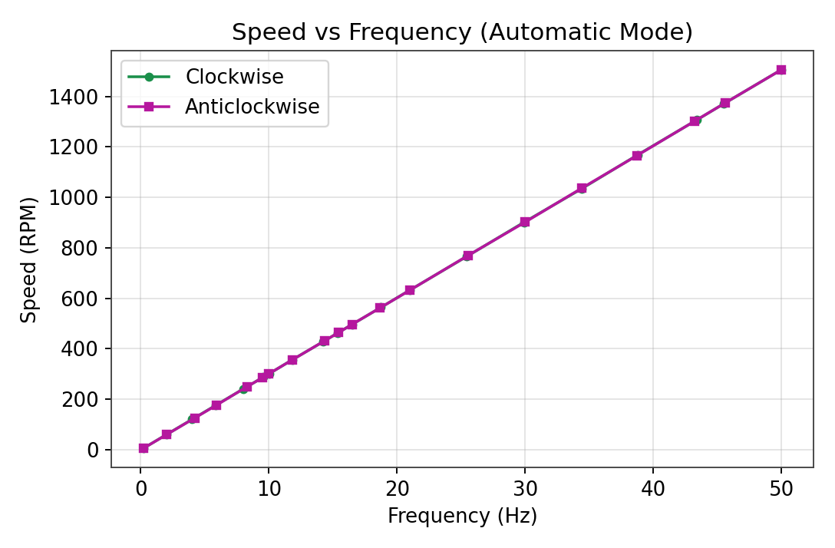
Fig. 8 — Speed vs frequency, Automatic mode, CW and ACW.

Observations
Parameter | Observed Trend | Interpretation
Voltage vs frequency | Rises linearly to 230 V at 50 Hz in both directions. | Confirms V/f control is direction-independent, as expected — the control law acts on magnitude, not on rotation sense.
Current | Rises steeply from ≈0.65 A up to ≈8 Hz, then flattens near 1.19–1.20 A; CW and ACW traces are almost indistinguishable. | Unlike the Manual-mode sweep, the very first Automatic-mode point is already at a small non-zero frequency (0.19–0.2 Hz) rather than a true 0 Hz ‘enable instant’, so the isolated high-current transient seen in Manual mode is not captured here — supporting the reading that that spike was a brief enable transient rather than a sustained operating point.
Speed vs frequency | Near-perfectly linear and overlapping for CW and ACW, reaching ≈1506–1507 RPM at 50 Hz. | Confirms the motor tracks synchronous speed symmetrically in both directions, with negligible no-load slip.
DC-link voltage | Stays within 328–336 V for both directions. | As in Manual mode, the rectifier/capacitor stage regulates the bus well regardless of rotation sense or control mode.
CW vs ACW comparison | The two directions agree to within a few RPM / a few hundredths of an ampere at every point. | Indicates a symmetric inverter switching pattern and no significant mechanical asymmetry (e.g. bearing drag) between directions.

Comparison: Manual vs Automatic Mode (Clockwise)
Because frequency is set discretely by hand in Manual mode and continuously by the potentiometer in Automatic mode, comparing the two is a check that the control law itself — not the means of setting the set-point — is what fixes the steady-state behaviour.
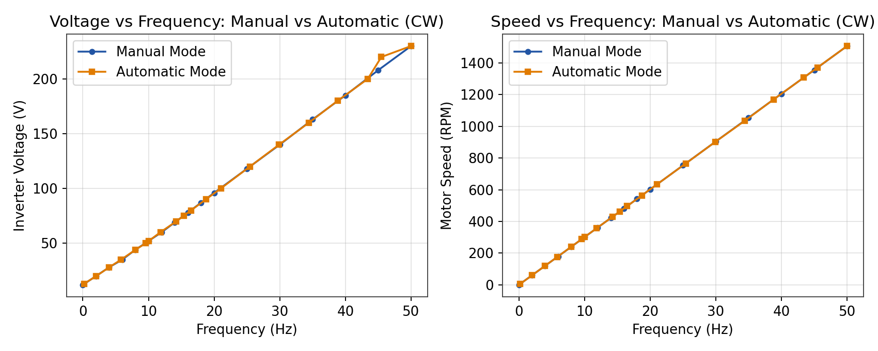
Fig. 9 — Voltage and speed vs frequency: Manual vs Automatic mode (CW).
The two data sets lie essentially on top of one another for both voltage and speed, confirming that steady-state V/f behaviour depends only on the frequency reached, not on how that frequency was arrived at (stepwise vs continuous).

Discussion of Non-Ideal Characteristics
Several deviations from the idealised, constant-V/f, zero-loss picture of the motor and drive are visible in the data and are discussed below.

1. Non-zero current at no load, and the 0 Hz transient
An ideal, unloaded motor would draw negligible current, yet the steady no-load current here settles near 1.20 A once past ≈10–12 Hz. This current is mainly the magnetising current Im needed to establish the rotating field, plus a small loss component covering iron losses (hysteresis and eddy current) and mechanical losses (bearing friction, windage); it must be supplied even though no mechanical load is coupled to the shaft. Superimposed on this is the isolated 1.60 A reading recorded at the very first Manual-mode point (0 Hz, drive just enabled) before it drops to 0.92 A at 2 Hz — the Automatic-mode sweep, whose first point is already at a small non-zero frequency, shows no such spike, so this is best read as a brief enable/DC-magnetising transient caught in that single manual reading rather than a genuine 0 Hz steady-state current.

2. Voltage boost and departure from constant V/f at low frequency
Although the drive settles to a V/f ratio of about 4.6–4.9 V/Hz beyond ≈10 Hz — matching the rated 230 V/50 Hz — the ratio is far higher at the lowest frequencies (≈10 V/Hz at 2 Hz). This is an intentional IsRs (stator-resistance-drop) compensation, or ‘voltage boost’, built into the drive: without it, the voltage actually reaching the air-gap flux at low frequency would be too small to produce useful starting torque.

3. DC-link voltage ripple
The DC-link voltage, ideally a perfectly smooth bus, was instead observed to vary by only about 5–7 V (roughly 2%) around a mean of ≈332–333 V across both modes and both directions. This small ripple, from rectifier conduction and inverter PWM switching, confirms that the capacitor bank filters the bus effectively even under the changing load the inverter presents as frequency is swept.

4. Frequency-dependent dynamic response
The step-response measurements described in the next section show that the effective time constant of the speed response is not fixed — it grows markedly with the target frequency, indicating that the motor-drive combination is not well described by a single linear, frequency-independent first-order model. This point is developed fully below.

Dynamic Response: Time-Constant Evaluation
The panel meters cannot be logged automatically, so the start-up transient of the speed response was instead captured on video at four frequency set points — 15, 30, 45 and 50 Hz — with the camera framed on the drive's digital RPM indicator. Each Manual-mode run began from standstill; the frequency was set and the motor started, and the resulting rise in indicated RPM was recorded until it settled.

Method
Each clip was decomposed into individual frames and the four-digit RPM reading was read directly off each frame: first at a uniform 2 frames/second across the whole clip to build a complete, auditable speed-vs-time trace, then at up to 10 frames/second around the reference points that matter for τ. For every run, the reference instant t0 was taken as the last frame at which the indicator still read exactly zero, immediately before its sustained climb began — an objective, directly-observable marker that does not depend on judging exactly when a finger contacts a button on a low-angle phone video. The crossing time t63 — the first instant at which the indicator reached 63.2% of its settled final value — was found by linear interpolation between the two frames bracketing that value, and the effective time constant was computed as τ = t63 − t0.
Two genuine measurement artefacts were encountered and are worth recording. First, at very low actual shaft speed the small number of tachometer pulses available within the indicator's sampling window makes the displayed RPM noisy — isolated frames occasionally showed an implausible value (e.g. briefly dropping toward zero, or jumping above the local trend) before the reading resumed its climb; these all occurred well before the 63.2% crossing point used for each run, so they do not affect the τ values below, though they are visible as small kinks in Fig. 10. Second, the digital indicator does not update continuously — it holds a reading for 2–4 video frames (≈ 0.2–0.4 s) and then jumps, so a widely-spaced sample can straddle the true crossing point inaccurately; every τ below was therefore read from frames spaced 0.1 s apart in the immediate vicinity of the crossing, not from the coarser 0.5 s trace used for the overview plot.
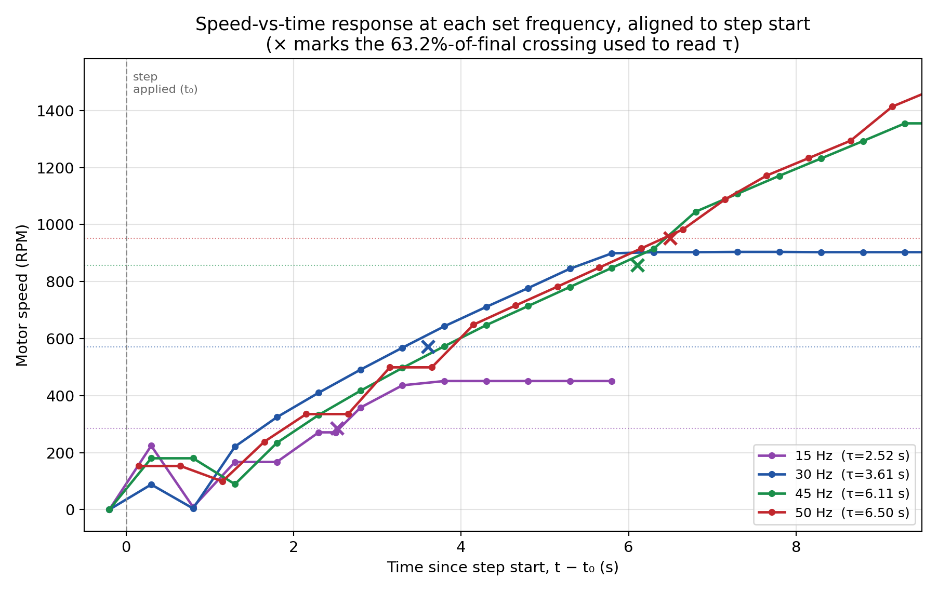
Fig. 10 — Full speed-vs-time trace for all four runs, time-aligned to each run's own step-start instant t0. Dotted lines mark each run's 63.2%-of-final target; × marks the interpolated crossing used to read τ. This is the complete data set underlying the results below — every point is a direct frame reading, not a fitted curve.
A first useful check is qualitative: the 30, 45 and 50 Hz curves climb at a visibly similar rate for the first ≈ 6 seconds and only separate because they are headed for different final speeds (903, 1355 and 1506 RPM respectively) — the higher-frequency runs simply have further to climb before flattening off, which by itself is enough to push their 63.2% crossing later in time. The 15 Hz run is the outlier: with a final speed of only 451 RPM it flattens out almost immediately and its crossing comes earliest of all.

Results
Set Frequency (Hz) | Final Speed, Nfinal (RPM) | Target for τ (0.632 × Nfinal) | Measured Time Constant, τ (s)
15 | 451 | 285 | 2.52
30 | 903 | 571 | 3.61
45 | 1355 | 856 | 6.11
50 | 1506 | 952 | 6.50
For auditability, the table below gives the exact frame pair each τ was interpolated from — these are the same numbers plotted as × markers in Fig. 10 and can be checked directly against the source video timestamps.
f (Hz) | t0 (s) | Frame before crossing | Frame after crossing | 63.2% target (RPM) | t63 (s) | τ (s)
15 | 4.70 | 271 @ 7.2s | 358 @ 7.3s | 285 | 7.22 | 2.52
30 | 3.70 | 568 @ 7.3s | 643 @ 7.5s | 571 | 7.31 | 3.61
45 | 1.20 | 848 @ 7.3s | 915 @ 7.4s | 856 | 7.31 | 6.11
50 | 0.85 | 916 @ 7.3s | 983 @ 7.4s | 952 | 7.35 | 6.50
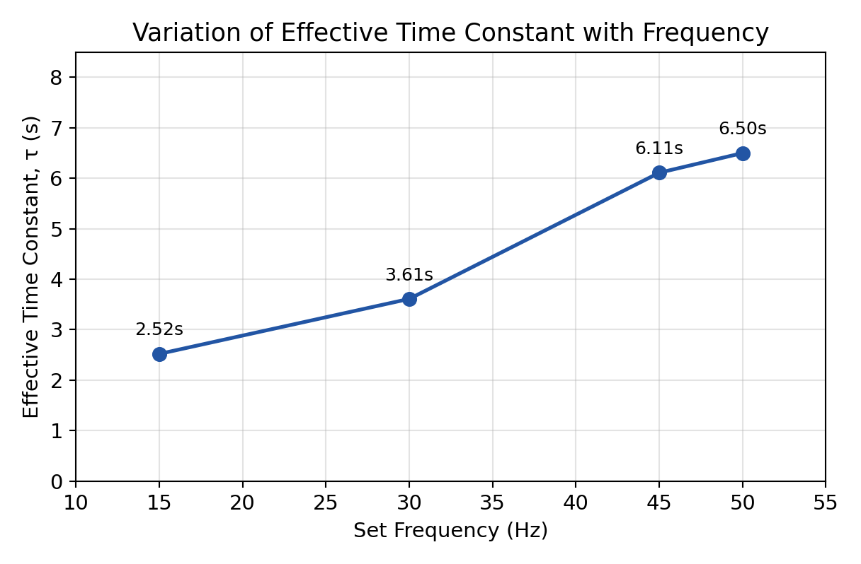
Fig. 11 — Effective time constant vs set frequency (summary of the table above).

Discussion
The effective time constant is clearly not fixed: it rises from 2.52 s at 15 Hz to 6.50 s at 50 Hz. Fig. 10 makes the reason visible directly, and it is a little more specific than “higher frequency = slower motor”:
- Similar climb rate, different distance. Over roughly the first 6 s after starting, the 30, 45 and 50 Hz traces are nearly superimposed — the motor accelerates at a broadly similar RPM/s regardless of target. Because τ is defined relative to each run's own final speed (63.2% of Nfinal), a run with a higher target simply has to cover a larger absolute RPM before it reaches that fraction, so its crossing falls later in time even at a similar climb rate. This alone accounts for most of the spread between 30, 45 and 50 Hz.
- Flattening near synchronous speed. Each curve's slope does visibly decrease as it nears its own plateau (most obvious for the 30 Hz trace after ≈ 6 s) — consistent with the electromagnetic torque available falling off as slip shrinks near synchronous speed. This is a genuine non-linearity, but Fig. 10 shows it is a second-order effect here compared to the ‘different final distance’ effect above.
- Scalar (V/f) control has no torque-angle feedback. Because V/f control only fixes flux magnitude and not the torque angle, the drive cannot actively shape a constant-acceleration profile the way a vector/field-oriented controller could; what acceleration is available is whatever the motor's own torque-slip curve happens to provide at each speed.
This is consistent with the manual's own observation that, although the dominant speed dynamics are typically first order, the associated time constant need not be — and, on this drive, clearly is not — the same at every V/f operating point. It is also why a simple 63.2%-of-final-value τ should be read as an effective, operating-point-specific descriptor rather than a single fixed system parameter: Fig. 10 (the actual data) is more informative than any single τ number, which is why it is reported alongside the summary table rather than in place of it.

Discussion
Across both Manual and Automatic modes, and both directions of rotation, the Siemens V20 drive reproduces the textbook V/f picture well: output voltage tracks frequency linearly with a full-scale ratio (4.6 V/Hz) matching the motor's own rating, the DC link stays tight around ≈332 V regardless of operating point, and speed tracks the synchronous-speed line 30f with the small negative offset expected of a lightly-loaded induction machine. Departures from the idealised model — the low-frequency voltage boost, the small but non-zero no-load current, the modest DC-link ripple, and the isolated 0 Hz current transient — are all explainable in terms of real, well-understood non-idealities (stator resistance drop, magnetising and iron/friction losses, rectifier/PWM ripple, and inverter-enable transients) rather than any fault in the equipment.
The one place the ideal picture clearly breaks down is in the dynamics: the effective speed time constant is strongly frequency-dependent, more than doubling between the 15 Hz and 50 Hz set points. This is an inherent property of scalar V/f control rather than of this drive specifically, and is the practical motivation for the vector/field-oriented control schemes referenced in the lab manual, which decouple flux and torque control and can therefore hold a much more uniform dynamic response across the full speed range.

Conclusion
The experiment confirmed correct operation of the V/f-controlled induction motor drive across both steady-state and dynamic tests. In steady state, the Siemens V20 was found to hold an essentially constant V/f ratio (≈4.6–4.9 V/Hz) above ≈10 Hz, with a deliberate low-frequency voltage boost below that, a tightly regulated ≈332 V DC link, and symmetric behaviour between clockwise and anticlockwise rotation and between Manual and Automatic control modes. In the dynamic tests, the speed step-response time constant was found, from frame-by-frame video analysis, to increase with set frequency — from 2.52 s at 15 Hz to 6.50 s at 50 Hz — driven mainly by higher-frequency runs having a larger absolute speed change to complete at a broadly similar climb rate, with a secondary contribution from the motor's non-linear torque–slip characteristic as each run nears its own synchronous speed. Both results are consistent with the theoretical expectations laid out in the lab manual.

